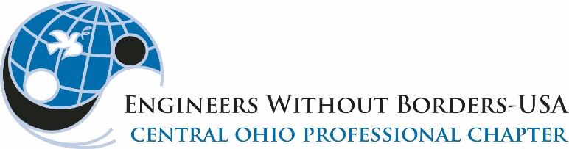
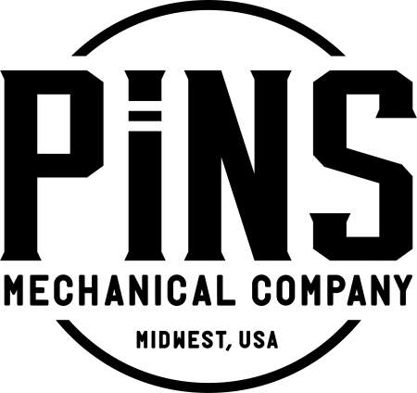

2023 EWB-COh FALL SOCIAL at PiNS
EVENT SPONSOR FORM

To make this event a success, Engineers Without Borders relies on the generosity of local engineering firms, contractors, trade vendors and civic organizations.
Please consider donating at one of the following levels:
□ | $500 Gold Level Event Sponsor  Recognition: (1) Your name and logo prominently displayed as a Gold tier sponsor of one of the bowling lanes; (2) Your name and logo displayed on EWB-COh Facebook page and website with link to your website.
□ | $200 Silver Level Event Sponsor  Recognition: (1) Your name and logo displayed as a Silver tier sponsor of one of the bowling lanes; (2) Your name and logo displayed on the EWB-COh Facebook page with a link to your website.
□ | Other Donations  You can donate company marketing items such as shirts, hats, golf balls, etc. for giveaways during the event. For more information, contact James Peltier at james.c.peltier@gmail.com

Two ways to become an Event Sponsor:
- Go online HERE or follow the QR code and enter your contact information in the Comments box

- Mail this form with your check to:
James Peltier | E.P. Ferris
2130 Quarry Trails Drive, 2nd Floor
Columbus, Ohio 43228

Please make check to Engineers Without Borders USA and write “Central Ohio Professional Chapter” on the memo line.

Company or Organization Name:

___________________________________________________________________

Contact Name: _______________________________________________________

Contact Phone: ______________________ Email:___________________________

More Information: James Peltier james.c.peltier@gmail.com 937-570-0731

